Q1:

0.3mm

step 1 step 2 step 3

Fiber sensor

Touch probe

Q2:

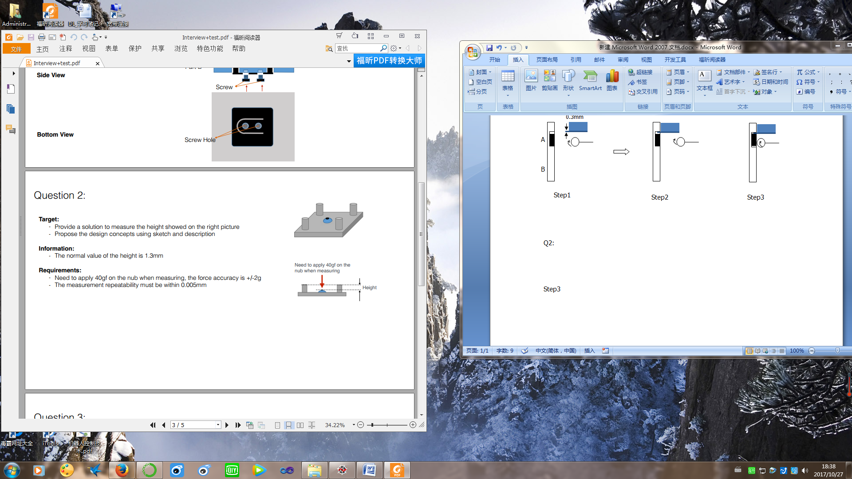

Q3:

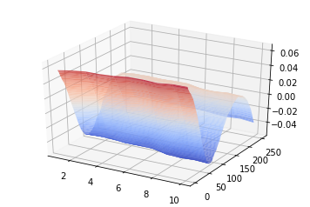

import csv

import numpy as np

import matplotlib.pyplot as plt

import mpl_toolkits.mplot3d

from scipy.optimize import leastsq

fp = open("Data and Image\\Flatness data_Question3.csv")

lines =csv.reader(fp,delimiter=',')

for row in lines:

data=row

newdata = []

for num in data:

newdata.append(float(num))

newdata = np.array(newdata)

z = newdata.reshape(10,250)

x,y = np.mgrid[1:10:10j,1:250:250j]

X = x.flatten()

Y = y.flatten()

Z = z.flatten()

def error(p):

a,b,c = p

return a*X+b*Y+c-Z

ax=plt.subplot(111,projection='3d')

ax.plot_surface(x,y,z,rstride=2,cstride=1,cmap=plt.cm.coolwarm,alpha=0.8)

plt.show()

r = leastsq(error,[0,0,1])

A,B,C = r[0]

r = np.sqrt(A**2+B**2+1**2)

d = (A*X+B*Y+C)/r

flattness = max(d)-min(d)

print("flattness",flattness)